January 2025
Products & Services
The new premium zirconia from VITA: A versatile material for perfect esthetics with multi-gradient technology.

Try it on quickly, approve of the fit and finally integrate it – that's how simple users and patients want their treatment results to be. Everything you need to achieve is now available in a single premium zirconia: the VITA YZ MULTI TRANSLUCENT Disc.

The innovative material combines the esthetic advantages of lithium disilicate with the reliable stability of zirconia.

Precise and versatile solution for all indication areas

VITA YZ MULTI TRANSLUCENT is the ideal choice for all indications, whether for monolithic full anatomical crowns, partial crowns, onlays, veneers or implant-supported bridges with up to 14 units. This means that storage can be significantly reduced. This high-quality raw material ensures stress-free sintering and a precise fit – including speed sintering of wide-span bridges in just 50 minutes.

Perfect esthetics with multi-gradient technology

For the latest generation of materials, the proven zirconia formulas of 4 mol-% (cervical) and 5 mol-% (incisal) yttrium oxide-stabilized tetragonal zirconia were combined in such a way that is suitable for the indications. The result is not only a natural, stepless shade and translucency gradient from the neck to the incisal area, but also a flexural strength that satisfies the requirements. In the dentine and cervical areas, where the forces acting on bridges are the highest, VITA YZ MULTI TRANSLUCENT offers flexural strength values of up to 1200 MPa and higher opacity to mask discolored dentine or metallic abutments. Robust and brilliant esthetics have never been so easy for monolithic restorations.

With VITA, the shade is right. Every single time.

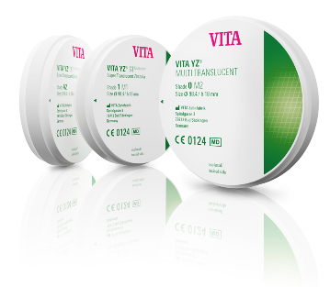
Getting the basic tooth shade right is crucial to ensure patient satisfaction. This unique VITA shade technology guarantees a PERFECT MATCH to the VITA shade guide. Available in 16 VITA classical A1-D4 shades and three bleach shades, VITA YZ MULTI TRANSLUCENT Disc offers the ideal solution for the patient's esthetic requirements. This ensures that the final insertion will be a success.

Fig. 1: The new VITA YZ MULTI TRANSLUCENT premium zirconia
VITA Zahnfabrik H. Rauter GmbH & Co. KG
VITA Zahnfabrik H. Rauter GmbH & Co. KG is a fourth-generation family business in the dental industry based in Bad Säckingen, in southern Germany. For 100 years, VITA has been developing, producing and distributing innovative, high-quality products and solutions for dental technology and dentistry. Worldwide, more than 600 employees work for VITA Zahnfabrik, with the objective of being closer to users and customers than anyone else. Areas of expertise range from analog and digital shade determination, denture teeth and veneering materials, press ceramics and CAD/CAM materials and furnaces and dental materials.
The needs of the user are also the focus of the new development of innovative system solutions for the functional and esthetic reproduction of tooth structure. With scientific expertise and targeted training programs, VITA supports and advises dental experts from more than 125 countries in their daily work.
This "perfect match" can be experienced in the lab and practice, from precise tooth shade determination to the finished restoration and cementation. VITA Zahnfabrik consistently pursues a path of excellence in developing better solutions for ideal prosthetics with continuous innovation and high-quality standards. In doing so, VITA Zahnfabrik offers innovative restoration options that contribute to an enhanced quality of life.

